**Project : Healthcare Telecommunication Systems**

***Phase 8: Data Management & Deployment***

1. ***Data Import Wizard***
2. Setup → **Data Import Wizard** → **Launch Wizard**.
3. Choose the object (e.g., Patient__c, Appointment__c).
4. Upload a CSV file and map columns to Salesforce fields.
5. Click **Start Import** and monitor progress in the Bulk Data Load Jobs page.

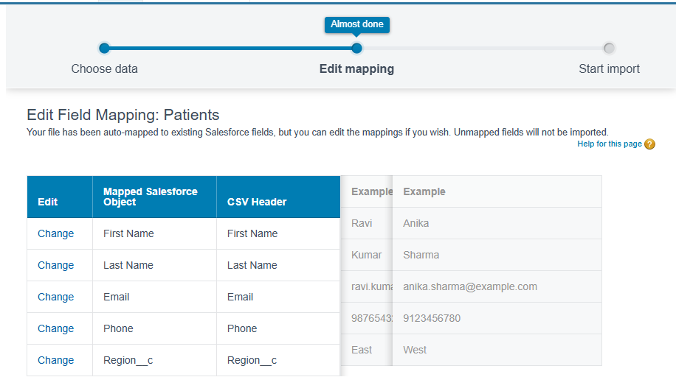

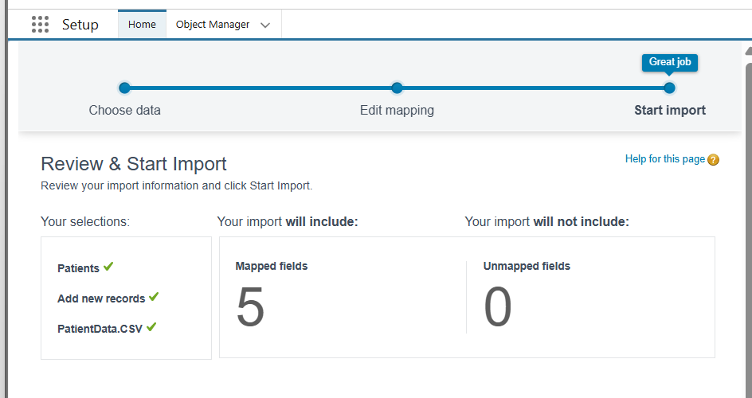

1. ***Data Loader***

**Purpose:** Desktop client for large or complex data operations (insert, update, upsert, delete, export).

1. Install Salesforce Data Loader.
2. Log in with your org credentials and security token.
3. Choose operation (Insert, Update, Upsert, Delete, Export).
4. Select object and CSV file, map fields, and run.

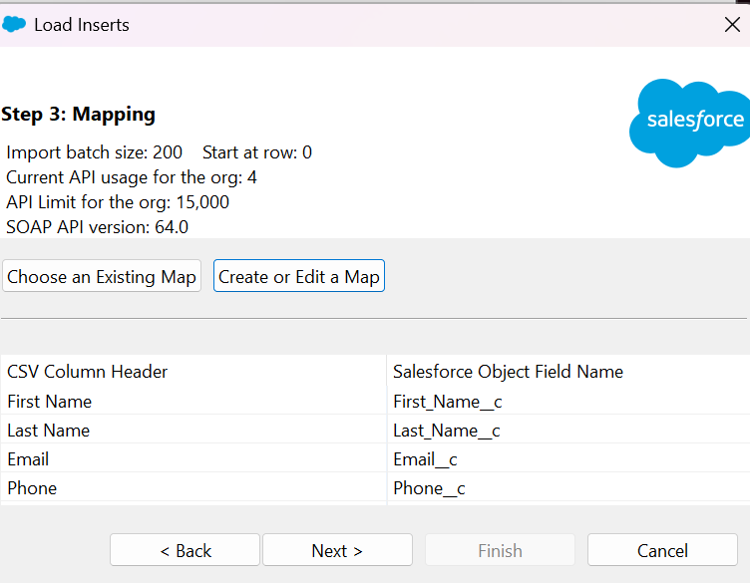

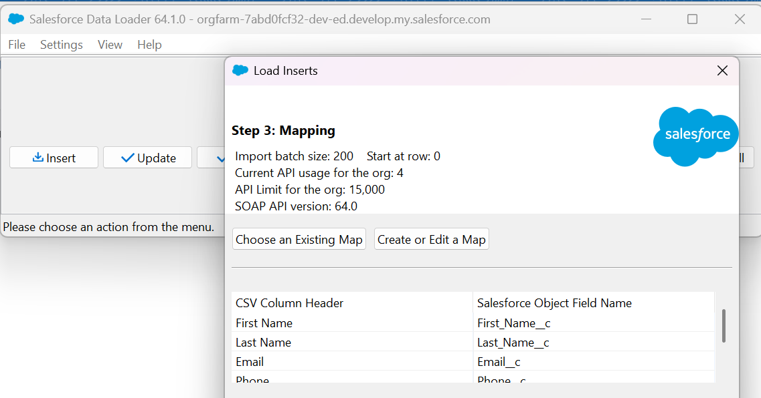

1. ***Duplicate Rules***

**Purpose:** Prevent or warn users about duplicate records (important for Patients or Doctors).

1. Setup → Duplicate Rules → New Rule.
2. Choose an object (e.g., Patient__c).
3. Define matching criteria (name + phone or email).
4. Choose Block or Allow & Report.
5. Activate the rule.

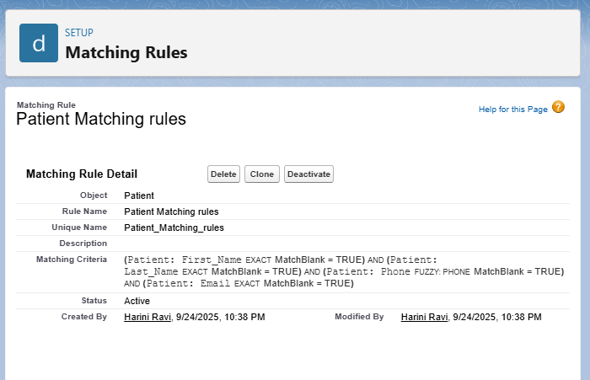

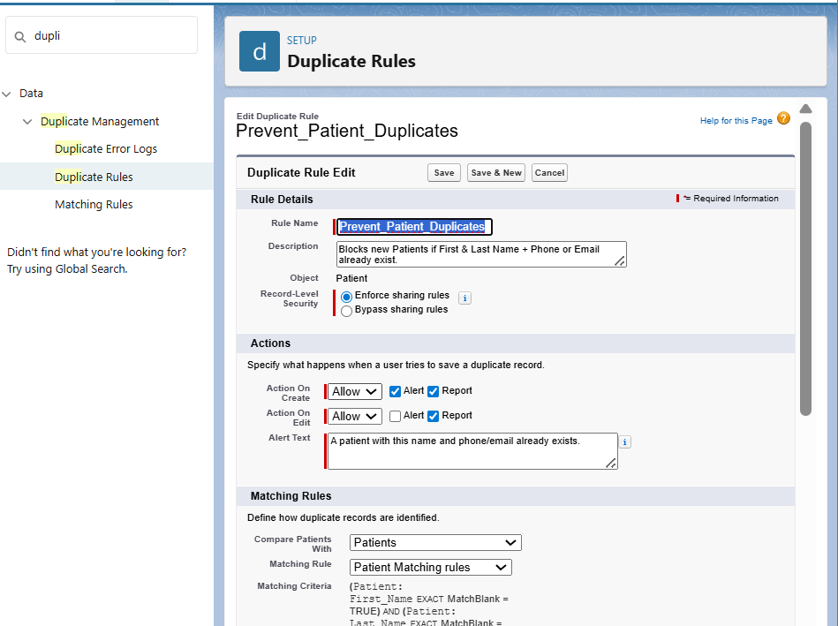

1. ***Data Export & Backup***

**Purpose :** Scheduled or manual backups of all org data.

1. Setup → Data Export
2. Choose Manual or Scheduled Export
3. Select critical objects (Patient__c, Doctor__c, Appointment__c, Payments__c, Tasks, Events)
4. Include optional attachments/files if needed
5. Start Export or Save Schedule
6. Wait for notification
7. Download the .zip file
8. Store securely and verify contents

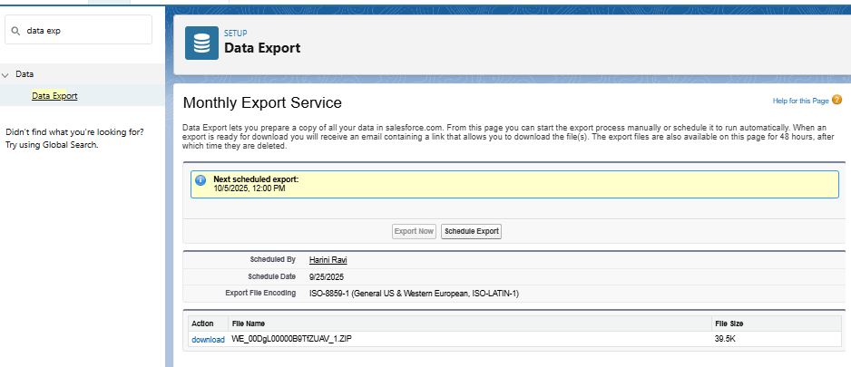

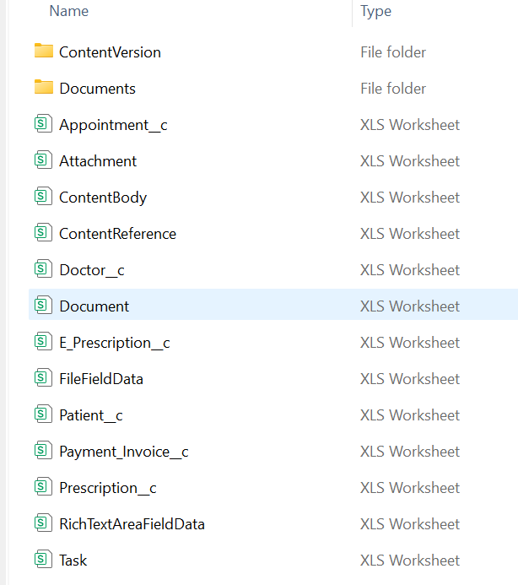

1. ***Change Sets***

**Purpose:** Deploy metadata (not data) between related Salesforce orgs.

1. Setup → Outbound Change Sets → New.
2. Add components (Objects, Fields, Apex Classes, LWCs, Profiles, etc.).
3. Upload to the target org.
4. In Target Org (Production): Setup → Inbound Change Sets → Deploy.
5. ***Unmanaged vs Managed Packages***

| **Type** | **Use Case** | **Features** |
| --- | --- | --- |
| Unmanaged | Open-source / template sharing | Editable code & metadata in subscriber org |
| Managed | Commercial apps / AppExchange | Versioning, upgrades, IP protection |

1. Go to **Setup → Quick Find → Packages → Packages → New**.
2. Enter **Package Name** and **Description**.
3. Choose the package type:
4. **Unmanaged** → for templates / sandbox sharing.
5. **Managed** → for commercial apps / production deployment.
6. Click **Save**.

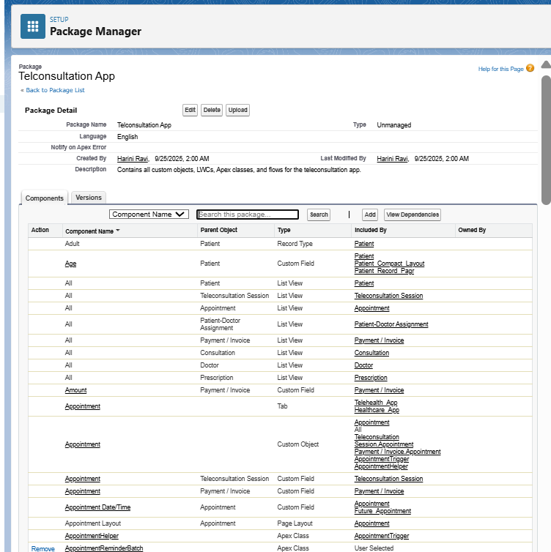

1. ***ANT Migration Tool***

**Purpose :** Script-based deployments using the Metadata API (for CI/CD).

1. Install Java JDK and Apache Ant.
2. Download the Salesforce ANT Migration Tool from Setup.
3. Create build.properties (username, password+token) and package.xml.
4. Commands:

ant retrieve – pull metadata.

ant deploy – push metadata.

1. Confirm success in Deployment Status of target org.
2. **Create package.xml**

**Code :**

<?xml version="1.0" encoding="UTF-8"?>

<Package xmlns="http://soap.sforce.com/2006/04/metadata">

<types>

<members>*</members>

<name>ApexClass</name>

</types>

<version>60.0</version>

</Package>

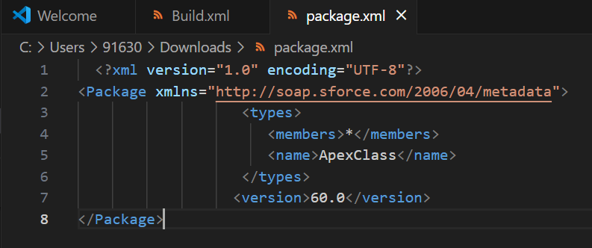

1. **Set Up build.xml**

**Code :**

<project name="SalesforceDeploy" default="deploy" basedir=".">

<property file="build.properties"/>

<taskdef resource="com/salesforce/antlib.xml" uri="antlib:com.salesforce">

<classpath>

<pathelement location="ant-salesforce.jar"/>

</classpath>

</taskdef>

<target name="retrieve">

<sf:retrieve unpackaged="package.xml" retrieveTarget="src"/>

</target>

<target name="deploy">

<sf:deploy deployRoot="src" rollbackOnError="true"/>

</target>

</project>

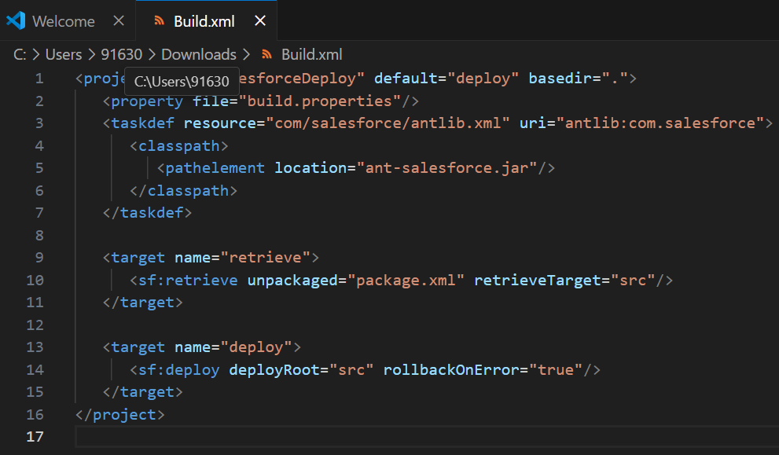

1. ***VS Code & SFDX (Salesforce CLI)***

**Purpose :** Modern development and CI/CD with scratch orgs.

1. Install Visual Studio Code + Salesforce Extensions Pack.
2. Install Salesforce CLI (SFDX).

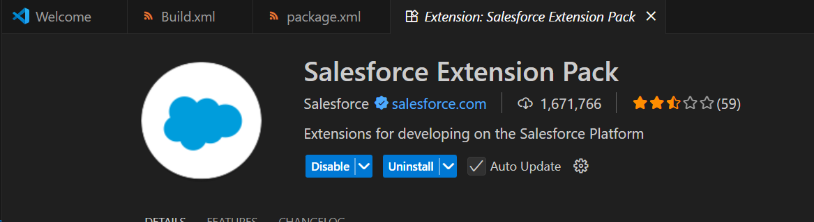

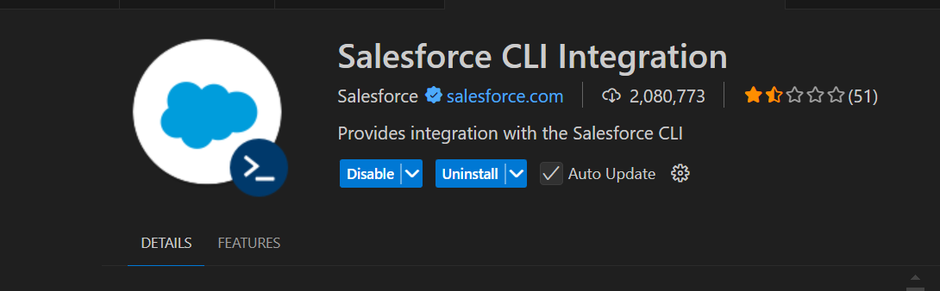

1. Retrieve/deploy metadata:

**Code :**

sfdx force:source:retrieve -m ApexClass

sfdx force:source:deploy -p force-app